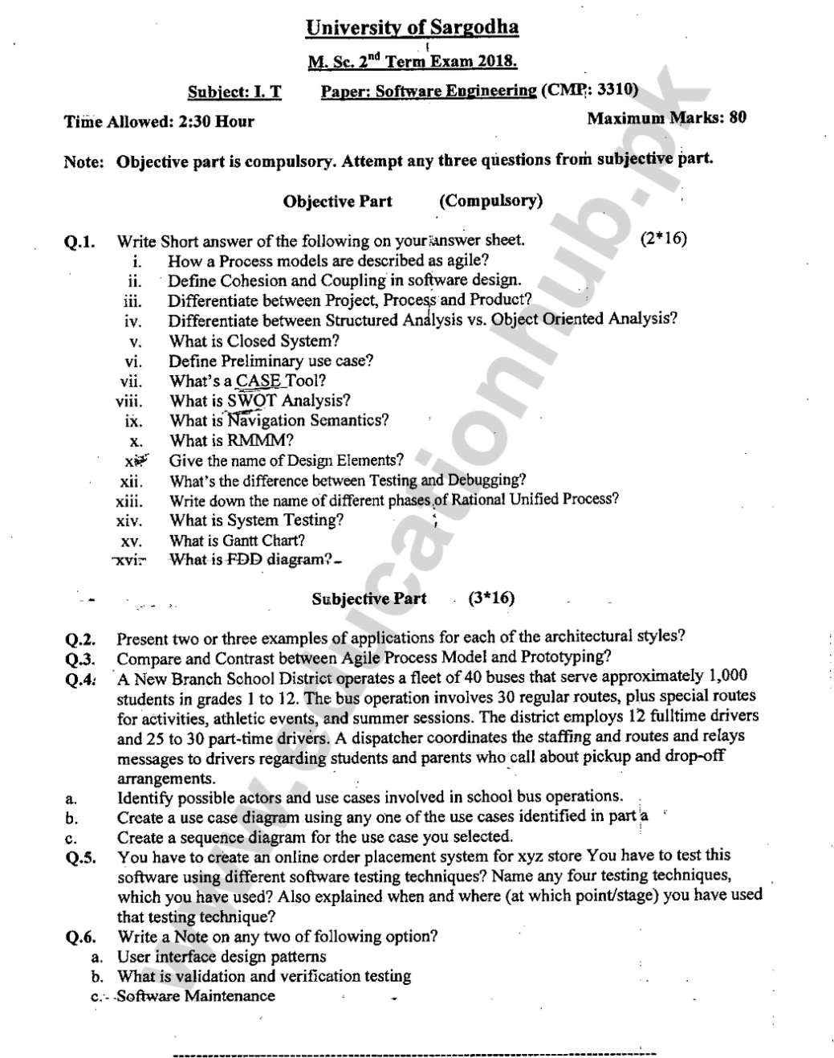

**SHORT ANSWERS:**

**1. How a Process models are described as agile?**

A process model is described as agile when at focus on four points:

1. Individual and team interactions over processes and tools.
2. Working software over comprehensive documentation.
3. Customer collaboration over contract negotiation.
4. Responding to change over following a plan.

**2. Define Cohesion and Coupling in software design.**

**Cohesion:** is an indication of the relative functional strength of a module. Cohesion is a natural extension of the information-hiding.

**Coupling**: is an indication of the relative interdependence among modules. **Coupling** refers to how strongly a software element is connected to other elements.

**3.Differentiate between Project, Process and Product?**

|  |  |  |
| --- | --- | --- |
| **PROJECT** | **PROCESS** | **PRODUCT** |
| A project is a temporary endeavor, with a clear definition of what needs to be delivered and by when. A project has a beginning and end date. | A Process is a set of related activities that leads to the production of the software. These activities may involve the development of the software from the scratch or modifying an existing system. | A product is designed to continually create value for customers by solving their problems. Products have more permanence, are living entities which we deliver quickly, iterate constantly, and are not something that we just walk away from. |

**4. Differentiate between Structured Analysis vs. Object Oriented Analysis?**

|  |  |
| --- | --- |
| **Structured Analysis** | **Object Oriented Analysis** |
| In this the focus is only on process and procedures. Modeling techniques used in it are DFD (Data Flow Diagram), Flowcharts etc. This approach is old and is not preferred. | In this we put more focus on capturing the real world objects in the current scenario that are of importance to the system. It stresses more on data structure and less on procedural structure. |

**5. What is Closed System?**

A system in which the specifications are kept secret to prevent interference from third parties. It inhibits third-party software from being installed; it keeps third-party hardware from interoperating with it, and it prevents third-party enhancements from improving the product.

**6. Define Preliminary use case?**

**7. What’s a CASE Tool?**

CASE tools are set of software application programs, which are used to automate SDLC activities. CASE tools are used by software project managers, analysts and engineers to develop software system.

**8. What is SWOT analysis?**

SWOT Analysis is a management review in strategic planning. SWOT stands for strengths, weaknesses, opportunities, and threats of a project going to start. A SWOT analysis usually starts with a broad overview of the whole system.

**9. What is Navigation Semantics?**

Navigation Semantics is a set of information and related navigation structures that collaborate in the fulfillment of a subset of related user requirements

**10. What is RMMM?**

RMMM is a risk management strategy that can be defined as a software project plan or the risk management steps. It can be organized into a separate Risk Mitigation, Monitoring and Management Plan. The RMMM plan documents all work performed as part of risk analysis and are used by the project manager as part of the overall project plan.

**11. Give the name of Design Elements?**

1. Interface Design Elements
2. Architectural Design Elements
3. Deployment Level Design Elements
4. Component Level Design Elements

**12. What’s the difference between Testing and Debugging?**

|  |  |
| --- | --- |
| **TESTING** | **DEBUGGING** |
| It is a process of finding bugs or errors in a software product that is done manually by tester or can be automated. | It is a process of fixing the bugs found in testing phase. Programmer or developer is responsible for debugging and it can’t be automated. |

**13. Write down the name of different phases of Rational Unified Process?**

1. Planning
2. Modeling
3. Construction
4. Development
5. Communication

**14. What is System Testing?**

System testing is a final testing process that verifies that all elements mesh properly and that overall system function/performance is achieved. A system test includes all typical processing situations and is intended to assure users, developers, and managers that the program meets all specifications and that all necessary features have been included.

**15. What is Gantt chart?**

Gantt chart is a horizontal bar chart that illustrates a schedule. **A Gantt chart is a visual view of tasks scheduled over time.** Gantt charts are used for planning projects of all sizes and they are a useful way of showing what work is scheduled to be done on a specific day. It helps Managers to view the start and end dates of a project in one simple view. Gantt charts were developed many years ago by Henry L. Gantt as a production control technique and still are in common use.

**16. What is FDD diagram?**

A functional decomposition diagram is a UML diagram that contains overall function or project and all of the necessary sub-tasks to complete the project. An **FDD**is a top-down representation of a function or process and you would use one to model a business functions and show how they are organized into lower-level process.